Assignment -2

**Python Programming**

|  |  |
| --- | --- |
| Assignment Date | 19 September 2022 |
| Student Name | Sangeetha S |
| Student Roll Number | 811019106032 |
| Maximum Marks | 2 Marks |

**Question-1:**

**Build a python code, Assume u get temperature and humidity values (generated with random function to a variable) and write a condition to continuously detect alarm in case of high temperature.**

|  |
| --- |
| **Solution:** |

import random

# temperature and humidity are in degeree celcious

hum=random.randint(10,99)

tem=random.randint(10,99)

if(hum>40 and tem>37):

print('humidity of:',hum ,'alarm is on')

print('temperature of:',tem ,'alarm is on')

elif(hum<40 and tem<37):

print('humidity of:',hum, 'alarm is detect')

print('temperature of:',tem ,'alarm is detect')

**Coding:**

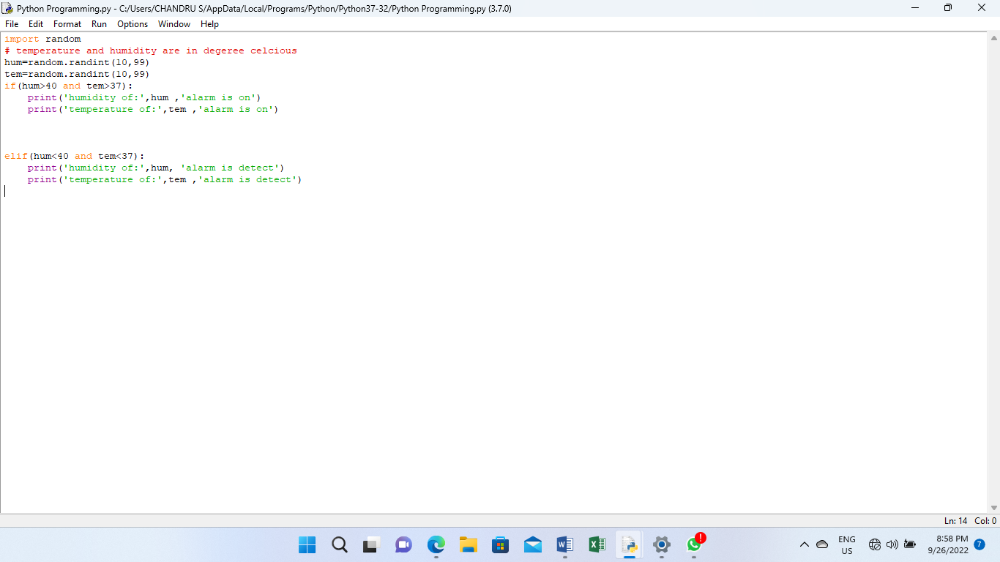

**Output:**

